INSTALL NODE.JS ON WINDOWS
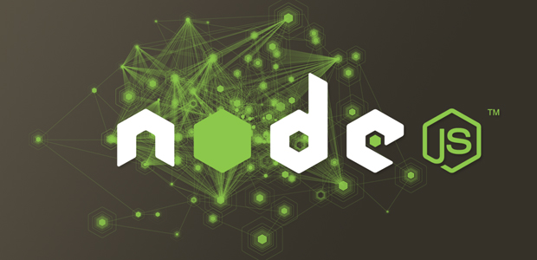
Tonight I was trying to install Node.js on Windows and couldn’t find any straightforward documentation. Reason is each new release of Node.js has multiple ways it can be setup. For instance, older versions required Cygwin and some people use a .exe file. None of these methods are optimal, so I’ve written a tutorial on how to install Node.js own Windows and test it in 6 steps with less than 10 minutes of your time.
Edit (10/19/2012): The below information is for Node 0.6 (including the code test sample). If you want to install the latest version just follow these simple steps and you should be good to go.
- Go to the NodeJS home page
- Click install to download the .msi installer package
- Run it and follow the instrucitons, you now have NPM (node package manager) and Node.js installed
- Reset your computer to get everything working in your command-line interface (CLI)

Windows Installation Instructions
To install Node.js on Windows is quite easy. You’ll just need to grab an installer package from their website and run it. Well it isn’t quite that easy, but its close.

Download node.msi Windows Installer
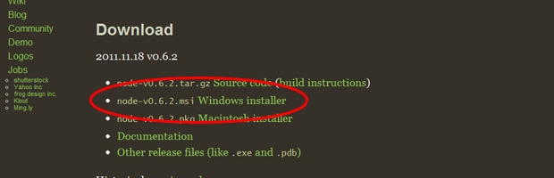
Go no Node.js‘s website and download the Windows .msi installer file. This is literally all you need setup everything.

Run node.msi Windows Installer
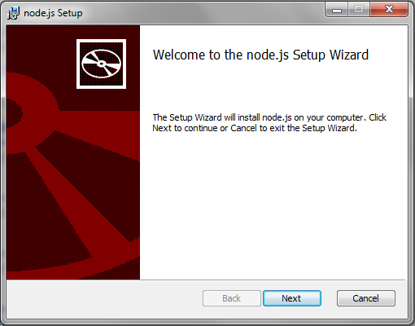
Run Node’s .msi file from anywhere on your computer. An installation window will appear. All you need to do is agree to and click okay on everything. If your Node.js install is corrupted, you can re-run this file and select repair to fix it.

Reset your computer
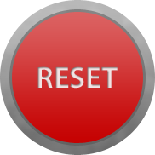
This is the step that everyone forgets. Once you’ve installed the .msi file you need to reset your computer. Failure to do so will prevent you from using Node in your command prompt. Wondering why? You need to flush Windows since its adjusting registry files and who knows what else under your computer’s hood.

Post Install Node.js on Windows
Just because you’ve installed Node.js doesn’t mean it works. In the next three steps, we’ll quickly walk through creating a test file and running it.

Create a Test File
?
test.js: Code example from http://nodejs.org home page.
1  2  3  4  5  6 | var http = require('http');  http.createServer(function (req, res) {  res.writeHead(200, {'Content-Type': 'text/plain'});  res.end('Hello World\n');  }).listen(1337, "127.0.0.1");  console.log('Server running at http://127.0.0.1:1337/');
To make sure your Node.js install works on Windows, create a simple hello world script with the above code. Call it test.js and store it somewhere easy to access on your computer. A location such as c:\node\test.js will make your life easier when accessing the file via Windows Command Prompt. If you use a different location you’ll have to adjust the following examples.

Run Windows Command Prompt
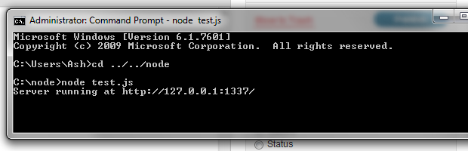
Run your Windows Command Prompt and relocate to test.js’s folder. Here you’ll need to run node test.js. Running this line of code causes Windows to activate the file and output a message.

Verify Install Node.js on Windows
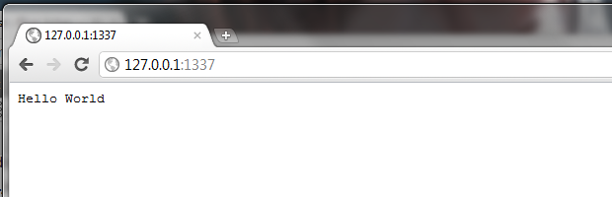
You probably noticed that running node test.js output a message identical/similar to Server running at http://127.0.0.1:1337/. To verify node is working correctly leave your command prompt running in the background, then copy and paste http://127.0.0.1:1337 into your browser. This should display an image similar to the above picture. If it still isn’t working walk back through the above steps or leave a comment below for more help.
If you made it through the above steps there is nothing left to install Node.js on Windows. Your computer should run it fine and no further configuration is necessary.
in

How to setup a node.js development environment on Windows

Install node.js
It’s easy to install node.js on Windows, just go to node.js official siteand download Windows installer, then execute the installer. Congratulations!!! You successfully installed node.js on Windows!!!

Install mongoDB
Go to mongoDB official site to download zip file for Windows, and unzip the contents to anywhere you like. MongoDB will read data at \data\db by default, but mongoDB won’t create this folder for us, so we must create it by ourself, you can create this folder in Windows Explorer, or type the following command in terminal:
1  2 | C:\> mkdir \data  C:\> mkdir \data\db
After creating \data\db, double click mongod.exe in your_mongodb_path\bin or type the following command in terminal to turn on mongoDB:
1  2 | C:\> cd your_mongodb_path\bin  C:\> mongod
Then you can double click mongo.exe or type the following command in terminal to get into administrative shell：
1  2 | C:\> cd your_mongodb_path\bin  C:\> mongo
Congratulations!!! You’ve successfully installed node.js and mongoDB on Windows!!!

Update node.js
Go to node.js’s official site and download Windows installer, then execute the installer. Then your node.js is updated.

Update mongoDB
Go to mongoDB official site to download zip file for Windows, and use the files in new zip file, then you can start to use the latest mongoDB. If you have question about installng or using mongoDB, you can check the Windows Quick Start on mongoDB official site :)

Setup a node.js development environment on other OS
If you want to setup a node.js development environment on Mac OSX Lion or Ubuntu 11.04, you can take a look at:
How to setup a node.js development environment on Mac OSX Lion
How to setup a node.js development environment on Ubuntu 11.04.

npm commands and node.js basics
Now you have setup a clean node.js development environment. Let’s have a quick look at how to use npm and learn some basics of javascript and node.js.

